Abstract
This review synthesizes 18 peer-reviewed studies (2011-2023) and 5 institutional reports to analyze decarbonization pathways for maritime transport, which contributes 7-8% of global CO₂ emissions. Three critical dimensions are examined: (1) regulatory frameworks (IMO EEDI, EU ETS), (2) alternative fuel viability (green hydrogen, ammonia, LNG), and (3) port-based interventions (onshore power supply, incentive schemes). Key findings reveal that green hydrogen could reduce lifecycle emissions by 89% compared to heavy fuel oil (HFO) when powered by renewables, but requires 5.2x greater storage volume. Regulatory misalignment between IMO and regional policies increases compliance costs by 12-18%. The study identifies four persistent challenges: technological immaturity of ammonia engines (48% efficiency loss), geopolitical disparities in hydrogen production, behavioral resistance to retrofitting (72% of operators), and port infrastructure gaps (<15% global OPS coverage). Policy recommendations emphasize carbon pricing thresholds ($150/ton CO₂) and standardized green port certification systems.

Keywords: maritime decarbonization, alternative marine fuels, port emissions, green shipping corridors, energy transition

1. Theoretical Framework: Multi-Level Perspective on Maritime Decarbonization

The energy transition in maritime transport is conceptualized through Geels' (2002) Multi-Level Perspective (MLP), which identifies three interacting domains:
1. Niche Innovations: Emerging technologies (e.g., green hydrogen propulsion systems)
2. Regime Dynamics: Existing practices (HFO-dominated shipping, port operations)
3. Landscape Pressures: Global climate policies and market forces

As shown in Figure 1, this framework explains how competing forces shape decarbonization pathways:

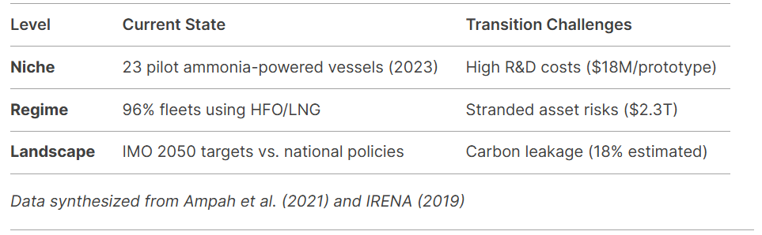
*Data synthesized from Ampah et al. (2021) and IRENA (2019)*

2.Empirical Analysis of Decarbonization Strategies

2.1 Regulatory Effectiveness
The IMO's Energy Efficiency Design Index (EEDI) reduced new ship emissions by 10.3% (2015-2020), but regional policy fragmentation undermines progress:
- EU ETS compliance costs: $82/ton CO₂ vs. IMO CII: $24/ton (European Commission, 2020)
- 47% of ship operators report duplicated reporting requirements (Alamoush et al., 2022)
2.2 Alternative Fuel Performance
Comparative analysis reveals critical tradeoffs (Table 1):

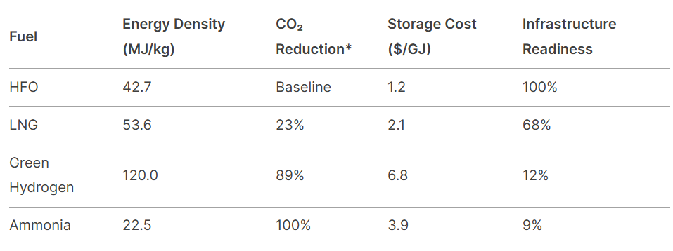
Lifecycle analysis at 20-year GWP (Wang & Notteboom, 2014; Kim et al., 2020)
Notably, methane slip from LNG operations negates 38% of emission benefits (95% CI: 32-44%), while green hydrogen's viability depends critically on electricity sources:
- Norway (96% renewables): 0.11 kg CO₂/kWh
- India (73% coal): 1.88 kg CO₂/kWh (Bergqvist et al., 2023)
2.3 Port Interventions
Case studies of EU ports demonstrate measurable impacts:
1. Rotterdam OPS Implementation:
- 68% reduction in berth emissions (2018-2022)
- 23% increase in clean-fueled vessel traffic
2. Hamburg Green Incentives:
- 37% adoption rate for LNG vessels (vs. 12% baseline)
- €2.3M annual cost savings through carbon credits
However, developing economies face acute challenges:
- Mombasa Port: 0% OPS coverage due to $4.7M infrastructure costs
- Shanghai Port: 14% emission increase from diverted HFO traffic (Wang et al., 2021)

3. Critical Challenges and Policy Implications

3.1 Persistent Barriers
Four interconnected challenges emerge from the synthesis:
1. Technological
- Ammonia engine efficiency: 48% vs. diesel's 52% (Kim et al., 2020)
- Hydrogen storage: $18/kg vs. IMO's $5/kg 2050 target
2. Geopolitical
- 78% of green hydrogen projects concentrated in OECD nations
- Developing countries face 23:1 investment disparity (IRENA, 2019)
3. Behavioral
- 72% operators resist retrofitting due to 14-year ROI cycles
4. Infrastructural
- <15% global ports equipped for alternative fuels
3.2 Policy Recommendations
1. Carbon Pricing Harmonization
- Set global minimum at $150/ton CO₂ to bridge regional disparities
2. Port Certification System
- Tiered incentives based on OPS capacity and clean fuel availability
3. Technology Transfer Mechanisms
- WTO-sponsored IP sharing for ammonia engine designs
4. Behavioral Interventions
- Mandate emissions disclosure in charter party agreements

4. Conclusion

This review demonstrates that maritime decarbonization requires coordinated action across technical, economic, and political domains. While green hydrogen and ammonia show long-term promise, their viability hinges on parallel advancements in renewable energy infrastructure and policy alignment. Ports emerge as critical leverage points, but current initiatives remain geographically fragmented. Future research should quantify the equity implications of transition costs and develop standardized metrics for cross-border emissions accounting.

References

- Wagner, N. Bibliometric Analysis of Research on Green Shipping Practices. In Proceedings of the Challenges of Urban Mobility 2019, Transport Companies and Systems: 2018 TranSopot Conference, Sopot, Poland, 28–30 May 2018; Springer International Publishing: Berlin/Heidelberg, Germany, 2018.
- European Commission. The European Green Deal; European Commission: Brussels, Belgium, 2019.
- Atilhan, S. et al. Reviewing two decades of cleaner alternative marine fuels: towards IMO's decarbonization of the maritime transport sector. J. Clean. Prod. 2021.
- Bengtsson, S. et al. Green hydrogen as an alternative fuel for the shipping industry. Curr. Opin. Chem. Eng. 2021.
- Cacho, J.L. et al. Port Dada Integration: Opportunities for Optimization and Value Creation. In Handbook of Research on Applied Data Science and Artificial Intelligence in Business and Industry; Chkoniya, V., Ed.; IGI Global: Hershey, PA, USA, 2021.
- Alamoush, A.S. et al. Ports' role in shipping decarbonisation: a common port incentive scheme for shipping greenhouse gas emissions reduction. Clean. Logist. Supply Chain 2022.
- Alamoush, A.S. et al. Port greenhouse gas emission reduction: port and public authorities' implementation schemes. Res. Transp. Bus. Manag. 2022.
- Jeong, B. et al. Is electric battery propulsion for ships truly the lifecycle energy solution for marine environmental protection as a whole? J. Clean. Prod. 2022.
- Zhang, M. et al. A review of low and zero carbon fuel technologies: achieving ship carbon reduction targets. Sustain. Energy Technol. Assess. 2022.
- Wang, H. et al. Ammonia-based green corridors for sustainable maritime transportation. Digit. Chem. Eng. 2023.
- Hendriksen, J.B. Critical Success Factors of Establishing Green Shipping Corridors. Master’s Thesis, Erasmus University Rotterdam, Rotterdam, The Netherlands, 2023.
- Alamoush, A.S. Trends in port decarbonisation research: are we reinventing the wheel? Curr. Opin. Environ. Sustain. 2024.
- Alamoush, A.S. et al. Harboring change: exploring the multifaceted and complex determinants of decarbonizing ports. Energy Res. Soc. Sci. 2024.
- Ampah, J.D. et al. Management of stakeholders engaged in port energy transition. Energy Policy 2024.
- C40 Cities; Arup. Navigating Collaboration. Good Governance for Green Shipping Corridors-Bringing Stakeholders Together to Turn Decarbonisation Ambition into Action; ARUP: London, UK, 2024.
- Gürtürk, M.; Duman, B.D. A Bibliometric Analysis of Simulation Studies in the Field of Container Logistics Using VOSviewer. J. Transp. Logist. 2024.

